Updated January 2017
Registration Quick Reference Card for Employees/Associates

Contents
Registration 2
Activate Your Email Address 8
Activate Your Mobile Phone 8
Forgot Your User ID/Password? 9

Disclaimers:
- Employee registration does not apply to admin-only services such as General Ledger Interface, ADP Reporting, and Payroll QuickView.
- The registration process outlined in this document does not apply to RUN Powered By ADP® Employee Access®.
- The registration process will vary slightly for employees registering for ADP Retirement Services on the participant website at www.mykplan.com.

Registration
Welcome! ADP is committed to protecting your privacy and ensuring that only you can access your personal information. To assist us in meeting that commitment, you must register with us before using our services.
Before You Begin: You will need your registration code and the URL to access your ADP service login page. If you do not have this information, contact your organization’s administrator.
Your registration code's format and delivery method depend on your organization's setup:
- You receive a personal registration code (for example, b9a7q6re) in an email from ADP (SecurityServices_NoReply@adp.com) or shared by your administrator (verbally or in a secure communication). This code is valid for 15 days from the date of issue.
(Or)
- Your administrator provides a code in the format “CompanyID-companyspecificcode” (for example, CompanyID-200Alabama1943) in a secure communication.
Security Tip: To protect your personal information from fraud, be sure to use a known computer or mobile device with a trusted internet connection.
On the login page of your ADP service, click the link to register and create your ADP service account. Follow the instructions on the page.
Enter your personal registration code or your organizational registration code. If you do not recognize the name of your organization, select No and start over.

Enter your identity information.
Important: Based on your organization’s setup, ONE of the options will apply.
Option 1  If you entered an Organizational Registration code, the information requested might vary based on your organization’s setup.  Google™ reCAPTCHA challenge:  Click on the “I’m not a robot” check box and answer a quick challenge and prove you are human. | 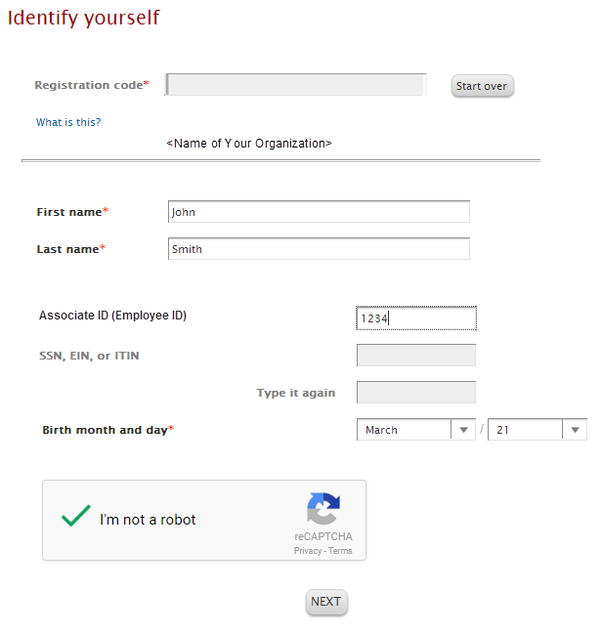
Option 2  If you entered a Personal Registration code, the information requested might vary based on the information in your record.  Note: Google™ reCAPTCHA challenge is not required when registering with a personal registration code. | 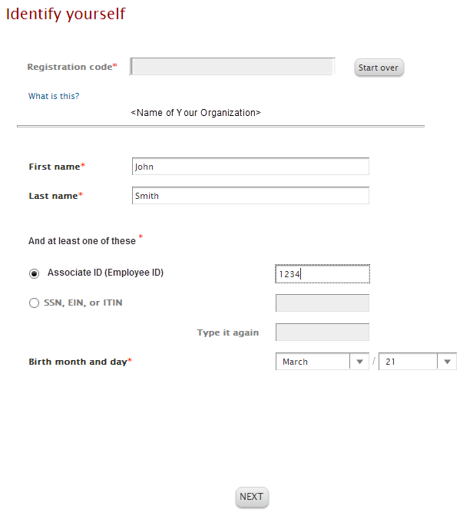

Complete the Google™ reCAPTCHA challenge.
This challenge is not required if you are registering with a personal registration code.
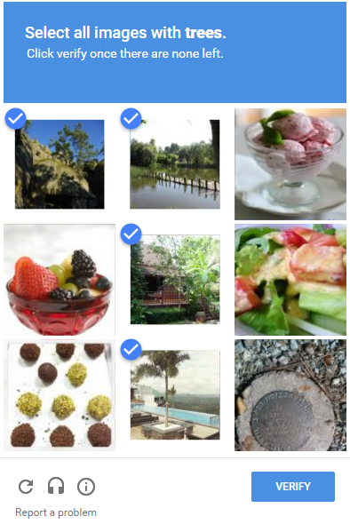

Sample Challenge
- Click on all the images that meet the required criteria.
- Select all responses that apply.

Need help?
- To get a new challenge, click the Refresh icon.
- To hear an audio challenge, click the Headphone icon.
- To learn more, click the Information icon.

Note: The appearance of the challenge might vary slightly based on your browser and its settings.
Additional Verification
Depending on your organization's setup, you may be required to provide additional verification.
Option 1 – Get and Enter a Code  - If your email address is unique within your organization, and  - You have access to the email address displayed during this process.  How this works:  You request a code to be sent to your email and enter it in the personal registration code field on this page within 15 minutes.  Don’t recognize the email displayed on this page or have trouble receiving the code? Use the option to answer identity questions, if available. | 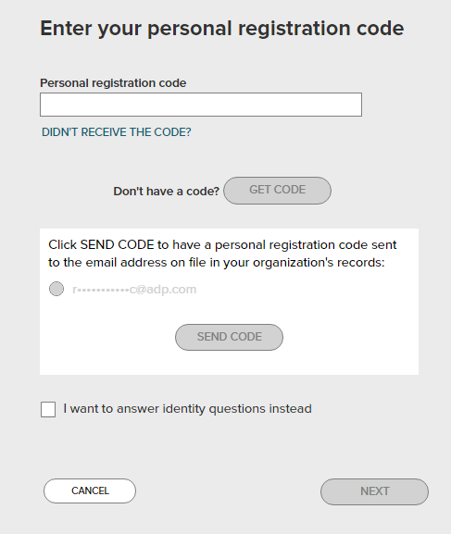
Option 2 – Answer Identity Questions  - If your email address in not unique within your organization’s records, or  - You do not recognize or have access to the email address displayed on the screen.  How this works:  You select a valid response to each question within 30 seconds.  These questions and their answer choices are generated from public records and other commercially available data sources. Your responses are not used for any purpose other than to verify your identity and are not shared with your organization. | 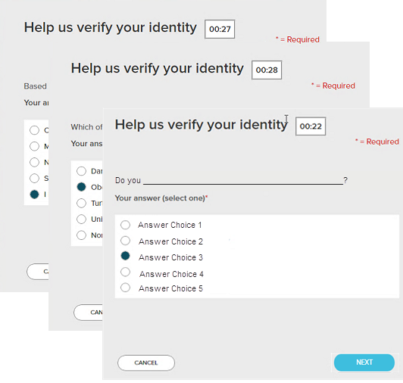

Complete the information required on this page to continue.
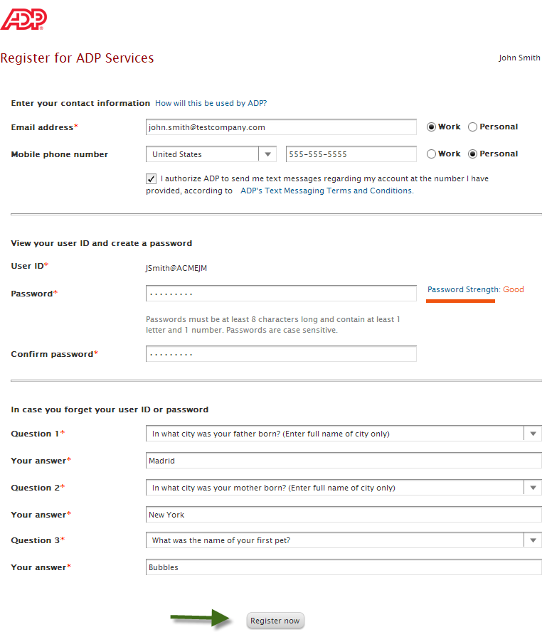
Enter answers that you will remember later.
Depending on the ADP services your organization has purchased, the option to create your user ID might be available.

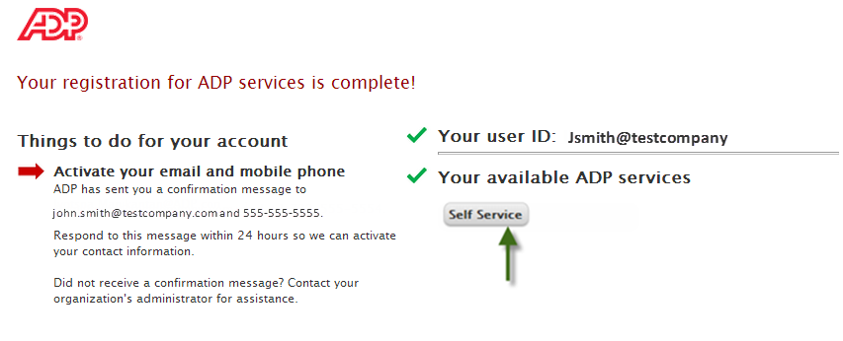
Your registration is complete. You can use your user ID and password to access your ADP service(s).
- Activate your email and mobile phone number to receive important notifications from your organization or ADP.
- Manage your account information to keep it accurate.

Activate Your Email Address
During registration, if you provided an email address that is not shared with others in your organization, look out for an activation email from ADP. Click the link in the email you receive from SecurityService_NoReply@ADP.com to complete the activation.
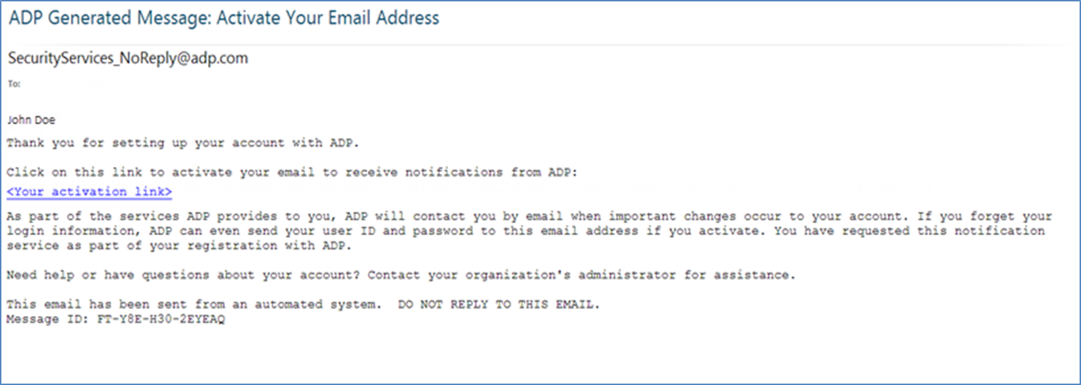

Activate Your Mobile Phone
During registration, if you provided a mobile phone number that is not shared with other users in your organization, look out for a text message from ADP. Reply with the code.
Note: In some countries, your activation process will differ; so, follow the instructions in the text message to activate your mobile number.

Need Help? Forgot Your Password?
If you forget your password, you can use the “Forgot your password?” link on your ADP service login page to reset your password.
During this process, you will be required to verify that you are the rightful owner of the account to protect your personal information.
Complete the following steps.
- Enter your user ID to identify yourself.
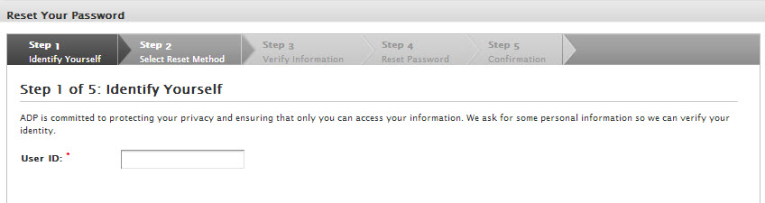
- Select the reset method.
  - Request temporary password to be sent as a text message to your activated mobile phone number.
  - Request temporary password to be sent via email to your activated email address.
  - Request to answer security questions and reset the password on the screen.
Note: If you have not yet activated your email address and/or your mobile phone numbers, the email and text message options will not be available to you. Use the option to reset your password on the screen.
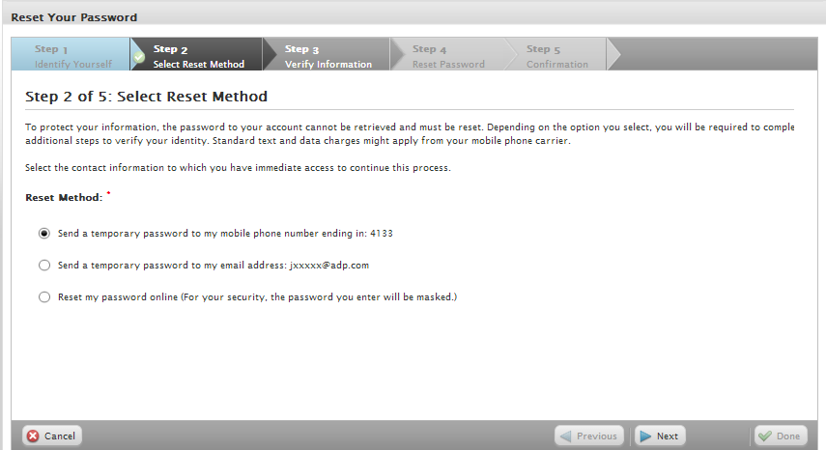
Note: Depending on the reset method you select, the next set of steps will differ.
Using your activated mobile phone number or your email address
- Enter the answer to your security question(s) to continue.
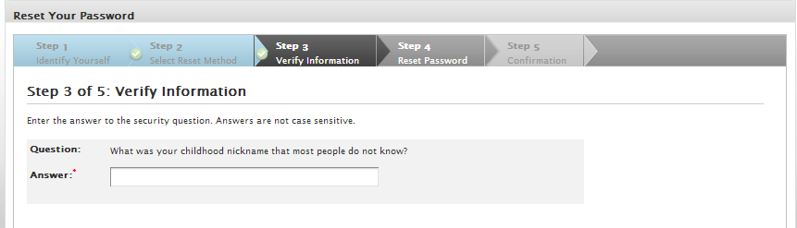
- Upon successful verification of your security answer(s), a temporary password will be sent to your mobile phone number or email address.
Use your temporary password to log in to your ADP service and choose your new password when prompted.
Note: If you are unable to reset your password, try a different option. If the problem persists, contact your organization’s administrator for assistance.

Using the option to reset your password online
- Select the option to be asked identity questions on screen.
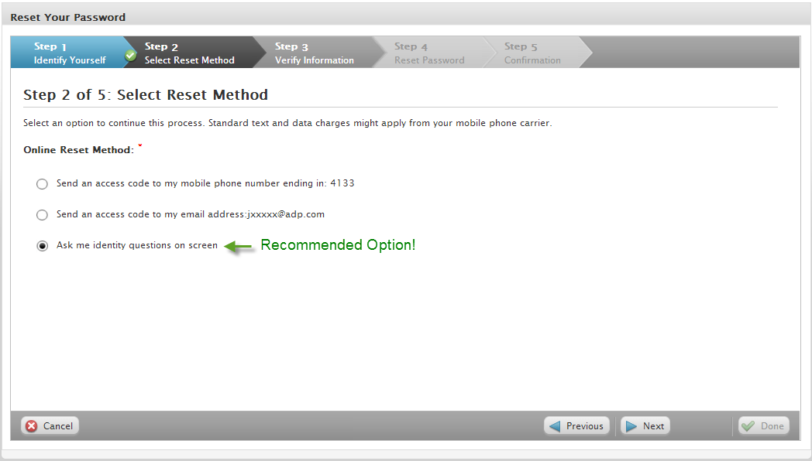
- Enter the identity verification information to confirm your identity.
Important: The options on this page may vary based on the ADP services your organization has purchased.
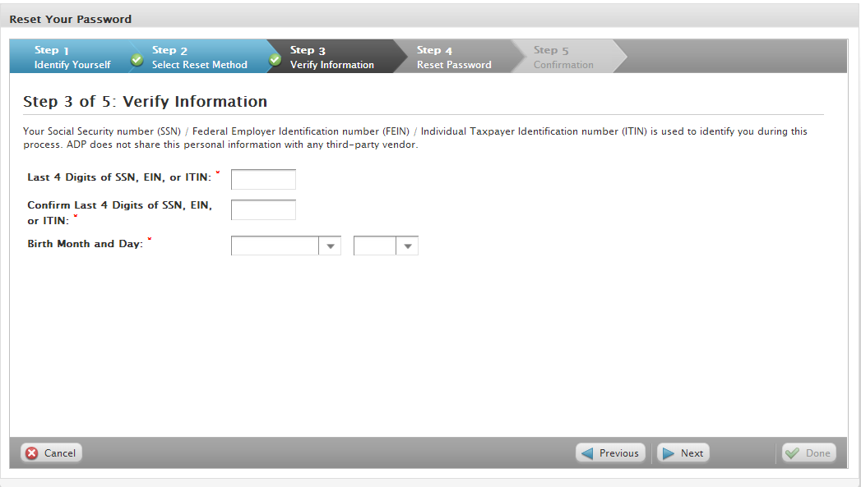

- Enter answers to your security questions to continue.
- Upon successful verification of your security answers, you will be prompted to select and confirm your new password.
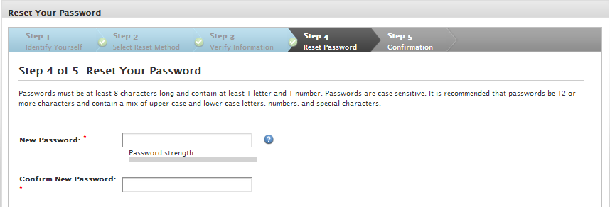
Congratulations! You have successfully reset your password. Use your new password to log in to your ADP service.
Note: If you are unable to reset your password, try a different option. If the problem persists, contact your organization’s administrator for assistance.

Need Help? Forgot Your User ID?
If you forget your user ID, you can use the “Forgot your user ID?” link on your ADP service login page to retrieve your user ID. During this process, you will be required to verify that you are the rightful owner of the account to protect your personal information.
Complete the following steps.
- Enter your first name and last name exactly as they exist in your organization’s records. Enter an email address or mobile phone number associated with your account.
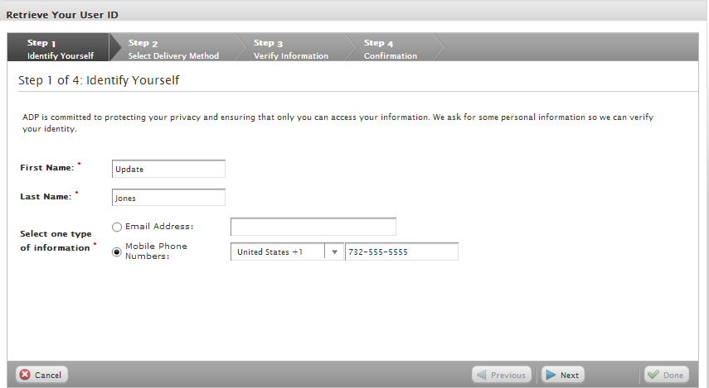
- Select the delivery method to retrieve your user ID:
  - Request your user ID to be sent via email to your email address.
  - Request your user ID to be sent as a text message to your mobile phone number.
  - Request to answer a security question and retrieve your user ID on the screen.
Note: If your email or mobile phone is shared with other users in your organization, you must use the option to retrieve your user ID on the screen.
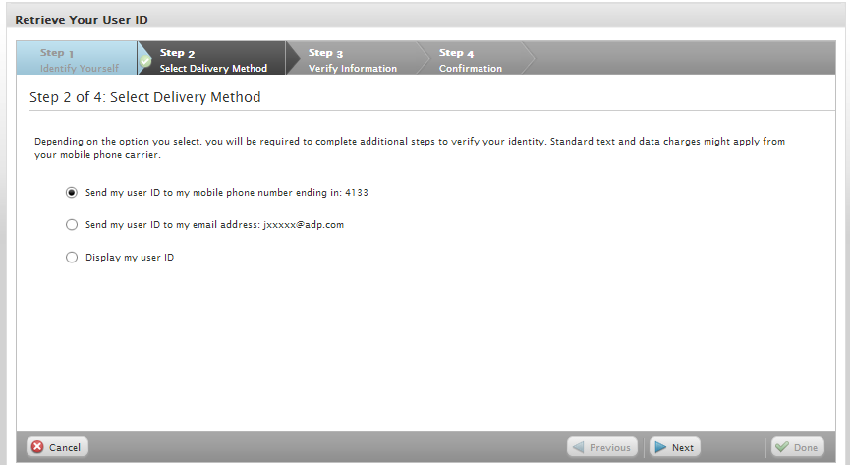
Note: Depending on the method you select, the next set of steps will differ.

Using your mobile phone number or your email address
- Verify that your mobile phone / email address is correct. Your user ID will be sent to your mobile phone number or email address.
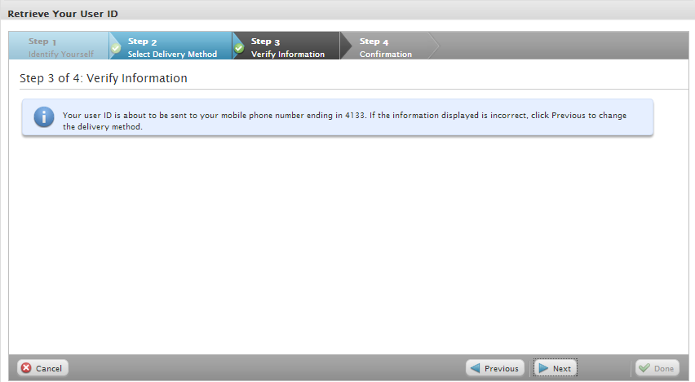
Congratulations! You have successfully retrieved your user ID. Use your user ID to log in to your ADP service account.
Note: If you are unable to retrieve your user ID, try a different option. If the problem persists, contact your organization’s administrator for assistance.
Using the option to display your user ID on the screen
- Enter the answer to your security question to continue.
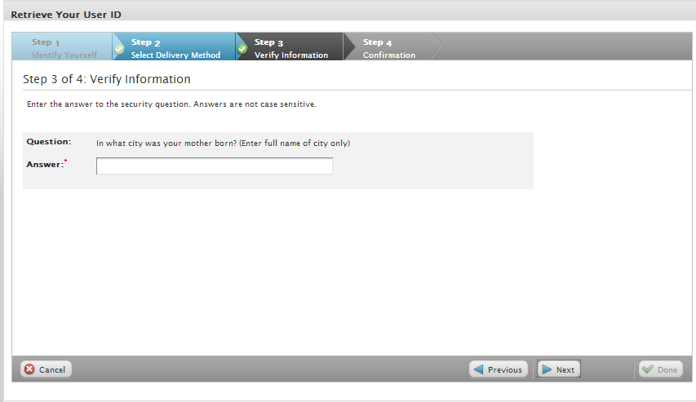
Upon successful verification of your security answer, your user ID will be displayed on the screen.
Congratulations! You have successfully retrieved your user ID. Use your user ID to log in to your ADP service account.
Note: If you are unable to retrieve your user ID, try a different option. If the problem persists, contact your organization’s administrator for assistance.

